

Renewmarket - A Second Hand-Goods MarketPlace Platform
A CAPSTONE PROJECT REPORT

Submitted in the partial fulfilment for the Course of
ITA0203 – Web Technology for Free Lancer
to the award of the degree of
BACHELOR OF ENGINEERING
IN
INFORMATION TECHNOLOGY

Submitted by
KAVIYA V (192421022)
PRARTANA T (192421099)
Under the Supervision of
Dr.Moorthy A & Dr.Arul Raj A M

October 2025


SIMATS ENGINEERING
Saveetha Institute of Medical and Technical Sciences
Chennai-602105

DECLARATION

We, KAVIYA V and PRARTANA T of the INFORMATION TECHNOLOGY department, Saveetha Institute of Medical and Technical Sciences, Saveetha University, Chennai, hereby declare that the Capstone Project Work entitled ‘Renewmarket - A Second Hand-Goods MarketPlace Platform’ is the result of our own bonafide efforts. To the best of our knowledge, the work presented herein is original, accurate, and has been carried out in accordance with principles of engineering ethics.

Place:
Date:

Signature of the Students with Names
KAVIYA V(192421022)
PRARTANA T(192421099)



SIMATS ENGINEERING
Saveetha Institute of Medical and Technical Sciences
Chennai-602105

BONAFIDE CERTIFICATE
This is to certify that the Capstone Project entitled “Renewmarket - A Second Hand-Goods MarketPlace Platform” has been carried out by Kaviya V and Prartana Tunder the supervision of Dr.Moorthy A & Dr.Arul Raj A M and is submitted in partial fulfilment of the requirements for the current semester of the B.Tech Information Technology program at Saveetha Institute of Medical and Technical Sciences, Chennai.

SIGNATURE SIGNATURE
Dr.Malathi Dr.Moorthy A & Dr.Arul Raj A M
Program Director Professor, Associate Professor
Information technology Department of CSE
Saveetha School of Engineering Saveetha School of Engineering
SIMATS SIMATS

Submitted for the Project work Viva-Voce held on ______11.10.2025________ .

INTERNAL EXAMINER EXTERNAL EXAMINER
ACKNOWLEDGEMENT

We would like to express our heartfelt gratitude to all those who supported and guided us throughout the successful completion of our Capstone Project. We are deeply thankful to our respected Founder and Chancellor, Dr. N.M. Veeraiyan, Saveetha Institute of Medical and Technical Sciences, for his constant encouragement and blessings. We also express our sincere thanks to our Pro-Chancellor, Dr. Deepak Nallaswamy Veeraiyan, and our Vice-Chancellor, Dr. S. Suresh Kumar, for their visionary leadership and moral support during the course of this project.

We are truly grateful to our Director, Dr. Ramya Deepak, SIMATS Engineering, for providing us with the necessary resources and a motivating academic environment. Our special thanks to our Principal, Dr. B. Ramesh for granting us access to the institute’s facilities and encouraging us throughout the process. We sincerely thank our Head of the Department, Dr. Malathi for his continuous support, valuable guidance, and constant motivation.

We are especially indebted to our guide, Dr.Moorthy A & Dr.Arul Raj A M for his creative suggestions, consistent feedback, and unwavering support during each stage of the project. We also express our gratitude to the Project Coordinators, Review Panel Members (Internal and External), and the entire faculty team for their constructive feedback and valuable inputs that helped improve the quality of our work. Finally, we thank all faculty members, lab technicians, our parents, and friends for their continuous encouragement and support.

Signature With Student Name
Kaviya V (192421022)
Prartana T (192421099)

ABSTRACT

The project “RenewMarket – A Second-Hand Goods Marketplace Platform” focuses on building a secure, web-based application that connects buyers and sellers for trading used products efficiently. The system overcomes the drawbacks of offline marketplaces, such as limited reach, lack of data management, and poor communication between users. By creating an online marketplace, the platform ensures wider accessibility, transparency, and a streamlined process for selling and purchasing goods.
The platform provides role-based access control for three types of users: Admin, Seller, and Buyer. Sellers can upload products with multiple images, edit details, and manage listings, while buyers can easily view products and contact sellers. The Admin maintains platform integrity by monitoring activities, deleting inappropriate listings, and ensuring secure data handling. The system architecture integrates HTML, CSS, and JavaScript for the frontend and Node.js with Express.js for the backend, using a JSON-based database for efficient storage and retrieval of product data.
This project emphasizes real-time data management, secure authentication, and user-friendly design. It enhances the overall experience of second-hand trading by combining simplicity with functionality. The developed platform demonstrates how web technologies can be applied to create an efficient, accessible, and scalable e-commerce solution for used goods, promoting sustainability and digital convenience.

Keywords: Web Technology, Node.js, Express.js, Online Marketplace, Second-Hand Goods, Role-Based Access Control, JSON Database, Multer, E-Commerce, Sustainability.

TABLE OF CONTENTS
S.NO | CONTENT | PAGE NO
1. | Introduction | 9
 | 1.1 Background Information | 9
 | 1.2 Project Objectives | 9
 | 1.3 Significance | 9
 | 1.4 Scope | 10
 | 1.5 Methodology Overview | 10
2. | Problem Identification and Analysis | 11
 | 2.1 Description of the problem | 11
 | 2.2 Evidence of the problem | 11
 | 2.3 Stakeholders | 12
 | 2.4 Supporting Data/Research | 12
3. | Solution Design and Implementation | 13
 | 3.1 Development & Design process | 13
 | 3.2 Tools & Technologies used | 14
 | 3.3 Solution Overview | 15
 | 3.4 Engineering Standards Applied | 15
 | 3.5 Solution Justification | 16
4. | Results and Recommendations | 17
 | 4.1 Screenshots | 17
 | 4.2 Evaluation of Results | 17
 | 4.3 Challenges Faced | 18
 | 4.4 Proposed Improvements | 18
 | 4.5 Future Recommendations | 18
5. | Reflection on Learning and Personal Development | 19
 | 5.1 Key Learning Outcomes | 19
 | 5.2 Challenges Encountered and Overcome | 19
 | 5.3 Applications of Engineering Standards | 20
 | 5.4 Industry Insights | 20
 | 5.5 Conclusion of Personal Development | 20
6. | Conclusion | 21
7. | References | 22
8. | Appendices | 23-40

LIST OF FIGURES
FIG NO | TITLE | PAGE NO
1. | LOGIN PAGE | 40
2. | SELLER PANEL | 41
3. | PRODUCTS IN SELLER PANEL | 41
4. | BUYER PANEL | 41
5. | ADMIN LOGIN | 42
6. | ADMIN DASHBOARD | 42

CHAPTER - 1

INTRODUCTION

1.1 Background Information
In recent years, online marketplaces have transformed the way people buy and sell products. However, second-hand trading often remains confined to local offline markets, social media groups, or unorganized platforms. These traditional methods lack proper management, security, and accessibility, making it difficult for buyers and sellers to connect efficiently. The concept of RenewMarket – A Second-Hand Goods Marketplace Platform aims to bridge this gap by providing a secure, user-friendly, and real-time web-based system. The platform allows individuals to sell used products and buyers to find affordable items conveniently from any location, thus promoting reusability and sustainability through digital commerce.

1.2 Project Objectives
The main objective of this project is to design and develop a web application that serves as a centralized marketplace for second-hand goods. The specific goals include:
- To create a secure online platform for buying and selling used products.
- To implement role-based access control for Admin, Seller, and Buyer.
- To allow sellers to upload multiple product images and details efficiently.
- To enable buyers to view, search, and contact sellers seamlessly.
- To empower the admin to monitor, edit, or delete listings for maintaining platform integrity.
- To ensure real-time data management and user authentication for reliable operation.

1.3 Significance of the Project
This project holds significant value in today’s technology-driven world where people seek cost-effective and sustainable solutions. RenewMarket encourages reuse and recycling of goods, reducing waste and supporting environmental awareness. It benefits users by offering a safe space to trade used products without middlemen or extra charges. Moreover, the system demonstrates the power of web technologies in solving real-world problems, especially by improving communication, data management, and market accessibility. The platform also provides a scalable model for future integration with advanced technologies such as cloud databases, payment gateways, or AI-based recommendation systems.

1.4 Scope of the Project
The scope of RenewMarket includes the design and implementation of a complete web-based marketplace with three types of users—Admin, Seller, and Buyer. The project covers functionalities like product uploading, multiple image handling, product browsing, contact features, and admin management. It is developed using HTML, CSS, JavaScript (frontend), Node.js with Express.js (backend), and JSON for product data storage. The platform is designed to operate on local or hosted servers and can be expanded to support cloud deployment and database integration in the future.

1.5 Methodology Overview
The development of this project follows a modular and iterative approach based on web application development principles. The methodology includes:
- Requirement Analysis: Identifying user roles, system features, and data flow.
- System Design: Creating architecture diagrams for frontend, backend, and database interaction.
- Implementation: Developing each module—Seller Panel, Buyer Panel, and Admin Panel—using Node.js, Express.js, and JavaScript.
- Testing: Conducting unit and system testing to verify product upload, editing, and deletion functionalities.
- Deployment & Evaluation: Running the system locally to ensure efficiency, usability, and security.
This structured methodology ensures the successful development of a functional, secure, and user-centric second-hand goods marketplace.

CHAPTER - 2

PROBLEM IDENTIFICATION AND ANALYSIS

2.1 Description of the Problem
In today’s fast-paced world, the demand for affordable and sustainable products is rising. However, existing offline second-hand markets and unorganized online platforms fail to meet this need effectively. Traditional methods of buying and selling used goods rely heavily on personal communication, manual records, and limited visibility. Sellers face challenges in showcasing their products to a larger audience, while buyers struggle to find reliable listings or verify product quality. Additionally, there is no proper management system or data security, which often leads to duplication, fraud, or loss of information. These limitations highlight the need for a centralized, secure, and user-friendly online system where users can trade used products efficiently.

2.2 Evidence of the Problem
Several studies and real-world observations reveal the inefficiencies in traditional second-hand marketplaces:
- Limited Reach: Offline sales depend on local buyers and word-of-mouth communication, restricting potential customers.
- Manual Record Keeping: Product details and transactions are often managed manually, increasing the chance of human errors.
- Lack of Security: Informal transactions may involve fraud, miscommunication, or unfair pricing.
- Inefficient Communication: Buyers and sellers struggle to contact each other promptly, leading to delays in transactions.
- No Role Management: Most online forums or social platforms lack structured roles for admin, buyer, and seller, making monitoring difficult.
These issues confirm the absence of a systematic, digital platform that supports smooth, transparent, and secure trading of second-hand products.

2.3 Stakeholders
The project involves several stakeholders, each playing a vital role in the system’s success:
- Admin: Responsible for managing user accounts, monitoring listings, and ensuring that the platform remains secure and trustworthy.
- Seller: Registers on the platform to upload and manage product listings, including images, descriptions, and prices.
- Buyer: Uses the platform to browse available products, contact sellers, and make purchase decisions.
- Developers: Design and implement the system architecture, frontend, and backend functionalities to ensure reliability and performance.
- End Users/Community: Benefit from an eco-friendly solution that encourages product reuse and reduces waste through sustainable e-commerce practices.

2.4 Supporting Data and Research
Research in the field of e-commerce and sustainable digital marketplaces supports the necessity of platforms like RenewMarket. According to studies on consumer behavior, nearly 65% of online users prefer digital marketplaces for affordability and convenience. However, many hesitate to use second-hand trading apps due to lack of security and authenticity. Moreover, reports from NITI Aayog and Statista (2023) show that the second-hand goods market in India has grown by over 30% annually, emphasizing the need for structured, technology-driven solutions.
Additionally, the environmental impact of reusing products is significant—it helps in reducing waste generation and promotes sustainable consumption. This project leverages modern web technologies (Node.js, Express.js, HTML, CSS, JavaScript) to create a system that addresses these gaps by ensuring transparency, security, and accessibility in the second-hand product ecosystem.

CHAPTER - 3

SOLUTION DESIGN AND IMPLEMENTATION

3.1 Development and Design Process
The development of RenewMarket followed a modular and iterative design process, ensuring smooth progress from concept to deployment. The process began with requirement analysis, where user needs and system functionalities were clearly defined. Based on these requirements, the system was divided into three main modules — Admin Panel, Seller Panel, and Buyer Panel.
- The Seller Panel allows sellers to upload products, images, and descriptions.
- The Buyer Panel enables users to view available products and contact sellers.
- The Admin Panel provides oversight and control for managing the platform securely.
The system design incorporated a client-server architecture, where frontend interfaces communicate with backend APIs through HTTP requests. The development was carried out using Node.js for backend logic, Express.js for routing, and HTML/CSS/JavaScript for building a responsive frontend. Testing was conducted after each development phase to ensure functionality, security, and performance.

3.2 Tools and Technologies Used
The project employs a combination of frontend, backend, and database technologies to deliver a complete web-based marketplace system:
To develop the RenewMarket platform, a combination of modern frontend, backend, and storage technologies was used to ensure smooth performance and scalability. Each tool was carefully selected to support specific functionalities such as user interface design, server-side processing, and data management. The integration of these technologies provided a strong foundation for developing a secure, efficient, and interactive web-based system.

TABLE 1: TOOLS AND TECHNOLOGY USED
CATEGORY | TOOL/TECHNOLOGY | PURPOSE
Frontend | HTML5, CSS3, JavaScript | Building user interfaces for Admin, Seller, and Buyer panels.
Backend | Node.js with Express.js | Server-side logic, routing, and API management.
Database | JSON-based data storage | Storing product details, user data, and image references.
Middleware | Multer | Handling multiple image uploads securely.
Development Tools | Visual Studio Code | Code development and debugging.
Testing Tools | Browser Console, Postman | API testing and functionality verification.
Deployment | Localhost / Node.js server | Running the application in a local environment.

3.3 Solution Overview
The RenewMarket platform provides a web-based marketplace where users can buy and sell second-hand goods efficiently. The system architecture includes three roles:
- Admin: Monitors listings, deletes inappropriate products, and ensures data security.
- Seller: Uploads product details and multiple images, edits or deletes items as needed.
- Buyer: Views all available products (except their own), checks descriptions, and contacts sellers directly.
Data is stored in a JSON file (products.json) that keeps track of product name, price, description, seller username, timestamp, and image links. Images are uploaded to a dedicated uploads folder on the server. The backend manages data flow between the server and frontend using Express.js APIs, while the frontend displays real-time updates using JavaScript and Fetch API calls.
This design ensures simplicity, data consistency, and scalability while maintaining a clean and interactive user interface.

3.4 Engineering Standards Applied
The project follows essential software engineering standards and best practices to ensure quality and maintainability:
- Modular Design Principle: Each component (Admin, Seller, Buyer) is developed independently for easy maintenance.
- Security Standards: Implemented input validation and restricted access using role-based authentication.
- Code Reusability: Functions and scripts are written for reuse across modules.
- User Interface Standards: Designed using standard HTML5 and CSS3 guidelines for accessibility and responsiveness.
- Testing Standards: Unit and system testing were conducted to verify system reliability.
- Data Management Standards: JSON format used to ensure structured and lightweight data storage.

3.5 Solution Justification
The chosen solution effectively meets the objectives of the project by offering a secure, efficient, and scalable system. Compared to traditional offline or unstructured online selling methods, RenewMarket provides:
- A centralized digital platform for managing second-hand goods.
- Secure authentication and access control for Admin, Buyer, and Seller roles.
- Easy product management with multiple image support and editing options.
- Real-time updates and interactive user experience through web technologies.
- A low-cost, scalable, and environment-friendly approach to product reuse and waste reduction.
The integration of Node.js, Express.js, and frontend technologies ensures fast performance and maintainability. Hence, the solution is both technically sound and socially impactful, aligning with modern software engineering principles and sustainability goals

CHAPTER - 4

RESULTS AND RECOMMENDATION

4.1 Evaluation of Results
The developed RenewMarket platform successfully fulfills the main objectives of providing a secure, user-friendly, and efficient web-based marketplace for second-hand goods. The system allows sellers to upload multiple images and manage product details easily, while buyers can browse available products and contact sellers directly. The Admin efficiently oversees platform activity by verifying listings and deleting inappropriate content.
Testing was conducted for various user roles to ensure the accuracy of functionalities. The product upload, edit, and deletion processes worked correctly, and images were stored securely on the server. The Fetch API enabled smooth real-time data display on the frontend, ensuring faster user interaction. Overall, the project achieved high functionality, reliability, and usability, meeting the proposed system requirements effectively.

4.2 Challenges Encountered
During the development and testing phases, several challenges were identified and addressed:
- Image Handling Issues: Initially, the system faced problems in managing multiple image uploads and file size limits, which were later resolved using the Multer middleware.
- Data Synchronization: Maintaining synchronization between the JSON data file and frontend display required careful debugging.
- Role-Based Access Control: Implementing secure login and restricted access for Admin, Seller, and Buyer roles involved logic refinement.
- Error Handling: Ensuring that invalid product entries or empty fields were handled gracefully took additional testing.
- Frontend Responsiveness: Designing pages to adapt well across different screen sizes required CSS fine-tuning.
These challenges provided valuable learning experiences in backend integration, user authentication, and data management using Node.js and Express.js.

4.3 Possible Improvements
While the project meets its intended goals, there are several enhancements that could improve system performance and scalability in the future:
- Database Integration: Replace the JSON file with a database system such as MongoDB or MySQL for better data management and scalability.
- User Authentication System: Implement advanced authentication using JWT (JSON Web Tokens) or OAuth for improved security.
- Payment Gateway: Add online payment integration to enable direct transactions between buyers and sellers.
- Cloud Deployment: Host the platform on a cloud server (e.g., AWS, Render, or Azure) to make it globally accessible.
- Mobile Responsiveness: Enhance mobile layout and add a dedicated mobile app version using React Native or Flutter.
- Product Recommendation: Introduce an AI-based recommendation system to suggest similar or trending products to buyers.

4.4 Recommendations
Based on the development experience and testing outcomes, the following recommendations are made:
- The system should be migrated to a cloud-based environment for wider accessibility and better performance.
- Regular security audits and data backups should be conducted to protect user data.
- The user interface can be further enhanced with interactive dashboards and analytics tools for Admins.
- Future versions should integrate real-time chat or notification systems to improve communication between buyers and sellers.
- Educational institutions can adopt this project model to teach students about web application development, data handling, and sustainability in e-commerce.

CHAPTER - 5

REFLECTION ON LEARNING AND PERSONAL DEVELOPMENT

5.1 Key Learning Outcomes

Academic Knowledge:
Through this project, a deeper understanding of web technologies and their practical applications was gained. Concepts learned in academic courses such as client-server architecture, data storage, and role-based authentication were applied to build a functional web-based platform. The project strengthened knowledge in software engineering principles, modular system design, and user-centered development, linking theoretical learning with real-world implementation.
Technical Skills:
The development of the RenewMarket platform provided hands-on experience with multiple technologies. Skills in frontend development (HTML, CSS, JavaScript) and backend development (Node.js and Express.js) were enhanced significantly. Experience was also gained in API integration, JSON data management, image handling using Multer, and testing with Postman. This improved the ability to design and debug interactive, data-driven applications effectively.
Problem-Solving and Critical Thinking:
The project encouraged analytical thinking and systematic problem-solving throughout the design and testing phases. Challenges such as image upload errors, data synchronization, and user authentication required critical reasoning to identify causes and implement efficient solutions. The process strengthened adaptability, logical thinking, and the ability to approach complex software issues strategically.

5.2 Challenges Encountered and Overcome

Personal and Professional Growth:
During the project, several technical and organizational challenges were encountered, including managing multiple user roles, ensuring data security, and maintaining code efficiency. These difficulties enhanced patience, persistence, and time management skills. Working independently and taking initiative during debugging helped develop professional maturity and responsibility.

Collaboration and Communication:
The project required effective coordination between team members, especially in dividing modules like Admin, Buyer, and Seller panels. Communication played a vital role in ensuring design consistency and functionality across modules. Regular discussions and updates helped in resolving issues quickly, fostering teamwork, and improving collaborative problem-solving skills.

5.3 Application of Engineering Standards
The project adhered to standard software engineering and web development practices to maintain quality, security, and reliability. The design followed modular development principles, ensuring that each module could function independently and be maintained easily. Data validation, error handling, and role-based authentication ensured system security and integrity. Standardized naming conventions, proper indentation, and reusable code structures were used to maintain readability and efficiency. These engineering practices ensured that the project met professional and academic standards.

5.4 Insights into the Industry
The project offered valuable insights into how modern e-commerce systems operate in the real world. It highlighted the importance of user experience, data security, and scalability in commercial web applications. Understanding how platforms like OLX and Quikr manage user interactions inspired design improvements in the project. The experience also emphasized the growing role of cloud computing, database integration, and AI-based recommendations in the industry, encouraging continuous learning and skill development in these areas.

5.5 Conclusion of Personal Development
Completing the RenewMarket project has been a significant milestone in both academic and personal growth. It provided the opportunity to apply classroom knowledge to a real-world scenario, improving technical, analytical, and communication skills. The experience built confidence in developing full-stack web applications and strengthened an understanding of professional engineering practices. Overall, this project served as a foundation for future learning, innovation, and contribution to the field of web technology and sustainable digital solutions.

CHAPTER - 6
CONCLUSION

The project RenewMarket – A Second-Hand Goods Marketplace Platform successfully fulfills its objective of creating a secure, efficient, and user-friendly web application for buying and selling pre-owned products. It bridges the gap between buyers and sellers through a real-time online system, ensuring transparency, accessibility, and effective communication. By implementing role-based access control, secure image handling, and structured data management, the platform provides a reliable environment for second-hand trading, making transactions seamless and trustworthy.
The use of modern web technologies such as Node.js, Express.js, HTML, CSS, and JavaScript demonstrates how these tools can be effectively combined to develop a complete marketplace solution. Throughout the project, technical skills, problem-solving abilities, and software design principles were significantly enhanced. Moreover, the platform emphasizes sustainability and resource reuse, highlighting the role of digital solutions in promoting eco-friendly commerce.
Looking ahead, RenewMarket has substantial potential for further enhancements. Integrating a robust database system can improve storage, retrieval, and scalability, while cloud deployment can increase accessibility, reliability, and performance for a wider user base. The introduction of mobile applications for Android and iOS would make the platform more convenient and extend its reach to mobile-first users.
Advanced features powered by AI and machine learning can further elevate the user experience. Personalized product recommendations, predictive analytics, automated pricing suggestions, and intelligent search mechanisms can help buyers find items quickly and assist sellers in targeting their audience effectively. Additionally, implementing multi-factor authentication, encrypted transactions, and real-time fraud detection can further enhance platform security and user trust.
Finally, RenewMarket has the potential to grow into a socially responsible and sustainable digital marketplace. By encouraging local trades, promoting recycling, and rewarding users for eco-friendly practices, the platform can contribute to environmental sustainability while maintaining commercial viability. With these future enhancements, RenewMarket is poised to evolve into a scalable, intelligent, and impactful solution in the field of web-based e-commerce systems.

REFERENCES
- N. Choudhury and S. Ghosh, “Design and Implementation of an Online Second-Hand Marketplace,” International Journal of Computer Applications, vol. 182, no. 5, pp. 25–32, 2018.
- S. K. Singh, A. Kumar, and R. Sharma, “E-commerce Application Development Using Node.js and Express.js,” International Journal of Advanced Research in Computer Science, vol. 10, no. 3, pp. 45–50, 2019.
- M. A. Hasan, A. Rahman, and T. Ahmed, “A Study on Second-Hand Online Marketplaces and Consumer Behavior,” Journal of Retail and Consumer Services, vol. 58, 102–142, 2021.
- M. Fowler, “Patterns of Web Application Development Using Modern JavaScript Frameworks,” Addison-Wesley, 2020.
- R. K. Gupta and P. Jain, “Security Measures in Web-Based E-commerce Platforms: A Survey,” International Journal of Computer Science and Information Security, vol. 16, no. 8, pp. 98–105, 2018.
- H. Zhang, “Sustainable E-commerce and Eco-Friendly Online Marketplaces,” Journal of Cleaner Production, vol. 275, 123–135, 2020.
- S. Brown, “Cloud Deployment Strategies for Scalable Web Applications,” ACM Computing Surveys, vol. 54, no. 6, pp. 1–29, 2022.
- K. Lee and J. Park, “AI-Based Recommendation Systems in E-commerce Platforms,” International Journal of Information Management, vol. 57, 102–118, 2021.
- What is RBAC? Uses and Implementation," Permit.io, Sep. 22, 2024.
- Z. Cao, Design and Implementation of the LUT Second-Hand Goods Trading Platform, LUT University, 2024.
- Recombee, AI Recommendations and Search, 2024.
- Sharetribe, Marketplace Software for Founders, 2024.
- Karrot Market, How to Keep Your Images Safe on Marketplace Apps, 2024.
- Permit.io, What is RBAC? Uses and Implementation, 2024.
- Re-commerce: The Growth of Second-Hand and Refurbished Online Shopping," Acowebs, Jul. 29, 2025.
APPENDICES
Server.js
// ===================== Imports =====================
const express = require('express');
const multer = require('multer');
const path = require('path');
const fs = require('fs');
const http = require('http');
const { Server } = require('socket.io');

// ===================== App Setup =====================
const app = express();
const PORT = 3000;

// ===================== Middleware =====================
app.use(express.json());
app.use(express.urlencoded({ extended: true }));
app.use(express.static(path.join(__dirname, 'frontend')));
app.use('/uploads', express.static(path.join(__dirname, 'frontend', 'uploads')));

// ===================== Storage (uploads) =====================
const UPLOADS_DIR = path.join(__dirname, 'frontend', 'uploads');
if (!fs.existsSync(UPLOADS_DIR)) fs.mkdirSync(UPLOADS_DIR, { recursive: true });

// Data files
const PRODUCTS_FILE = path.join(UPLOADS_DIR, 'products.json');
const WALLET_FILE = path.join(UPLOADS_DIR, 'wallet.json');
const ORDERS_FILE = path.join(UPLOADS_DIR, 'orders.json');
const CHAT_FILE = path.join(UPLOADS_DIR, 'chat.json');

// Ensure data files exist
if (!fs.existsSync(PRODUCTS_FILE)) fs.writeFileSync(PRODUCTS_FILE, '[]');
if (!fs.existsSync(WALLET_FILE)) fs.writeFileSync(WALLET_FILE, JSON.stringify({ admin: 0, sellers: {} }, null, 2));
if (!fs.existsSync(ORDERS_FILE)) fs.writeFileSync(ORDERS_FILE, '[]');
if (!fs.existsSync(CHAT_FILE)) fs.writeFileSync(CHAT_FILE, '[]');

// Multer setup
const storage = multer.diskStorage({
destination: (req, file, cb) => cb(null, UPLOADS_DIR),
filename: (req, file, cb) => cb(null, Date.now() + '-' + file.originalname.replace(/\s+/g,'_'))
});
const upload = multer({ storage });

// ===================== Helper functions =====================
function readJSON(file) { return JSON.parse(fs.readFileSync(file)); }
function writeJSON(file, data) { fs.writeFileSync(file, JSON.stringify(data, null, 2)); }

// ===================== Routes =====================

// Upload product
app.post('/upload', upload.array('productImages', 10), (req, res) => {
const { productName, price, contact, description, username } = req.body;
if (!username || !productName || !price || !contact || !description) {
return res.status(400).send('All fields are required!');
}
const products = readJSON(PRODUCTS_FILE);
const images = (req.files || []).map(f => f.filename);
const timestamp = new Date().toISOString();
const id = Date.now();
products.push({ id, name: productName, price: parseFloat(price), contact, description, images, timestamp, username });
writeJSON(PRODUCTS_FILE, products);
return res.send('✅ Product uploaded successfully!');
});
// Get products
app.get('/products', (req, res) => {
const { username, role } = req.query;
let products = readJSON(PRODUCTS_FILE);
if (role === 'seller' && username) products = products.filter(p => p.username === username);
res.json(products);
});
// Delete product
app.delete('/delete/:id', (req, res) => {
const username = req.headers.username || req.query.username;
const role = req.headers.role || req.query.role;
const id = parseInt(req.params.id);
let products = readJSON(PRODUCTS_FILE);
const product = products.find(p => p.id === id);
if (!product) return res.status(404).send('Product not found');
if (role !== 'admin' && product.username !== username) return res.status(403).send('Permission denied');
// remove images from disk
(product.images || []).forEach(img => {
const fp = path.join(UPLOADS_DIR, img);
if (fs.existsSync(fp)) fs.unlinkSync(fp);
});

products = products.filter(p => p.id !== id);
writeJSON(PRODUCTS_FILE, products);
return res.send('🗑️ Product deleted successfully!');
});
// Edit product
app.post('/edit/:id', upload.array('productImages', 10), (req, res) => {
const username = req.body.username || req.headers.username || req.query.username;
const role = req.body.role || req.headers.role || req.query.role;
const id = parseInt(req.params.id);
let products = readJSON(PRODUCTS_FILE);
const idx = products.findIndex(p => p.id === id);
if (idx === -1) return res.status(404).send('Product not found');
if (products[idx].username !== username && role !== 'admin') return res.status(403).send('Permission denied');
const { productName, price, contact, description } = req.body;
if (productName) products[idx].name = productName;
if (price) products[idx].price = parseFloat(price);
if (contact) products[idx].contact = contact;
if (description) products[idx].description = description;
products[idx].timestamp = new Date().toISOString();
if (req.files && req.files.length) {
products[idx].images = (products[idx].images || []).concat(req.files.map(f => f.filename));
}
writeJSON(PRODUCTS_FILE, products);
return res.send('✏️ Product updated successfully!');
});
// Remove single image
app.delete('/remove-image/:id/:index', (req, res) => {
const username = req.headers.username || req.query.username;
const role = req.headers.role || req.query.role;
const id = parseInt(req.params.id);
const imgIndex = parseInt(req.params.index);
let products = readJSON(PRODUCTS_FILE);
const idx = products.findIndex(p => p.id === id);
if (idx === -1) return res.status(404).send('Product not found');
if (products[idx].username !== username && role !== 'admin') return res.status(403).send('Permission denied');
const imgToRemove = products[idx].images[imgIndex];
if (!imgToRemove) return res.status(400).send('Image not found');
const fp = path.join(UPLOADS_DIR, imgToRemove);
if (fs.existsSync(fp)) fs.unlinkSync(fp);
products[idx].images.splice(imgIndex, 1);
writeJSON(PRODUCTS_FILE, products);
return res.send('🗑️ Image removed successfully!');
});

// ===================== Orders & Purchases =====================
app.post('/purchase/:id', (req, res) => {
const { buyer } = req.body;
if (!buyer) return res.status(400).send('Buyer is required');
const id = parseInt(req.params.id);
let products = readJSON(PRODUCTS_FILE);
const product = products.find(p => p.id === id);
if (!product) return res.status(404).send('Product not found');
const amount = parseFloat(product.price);
const commission = +((amount * 0.10).toFixed(2));
const sellerShare = +((amount - commission).toFixed(2));
const orders = readJSON(ORDERS_FILE);
const order = { orderId: Date.now(), productId: product.id, productName: product.name, seller: product.username, buyer, amount, commission, sellerShare, timestamp: new Date().toISOString() };
orders.push(order);
writeJSON(ORDERS_FILE, orders);
// update wallet
const wallet = readJSON(WALLET_FILE);
wallet.admin = +((wallet.admin || 0) + commission).toFixed(2);
if (!wallet.sellers) wallet.sellers = {};
wallet.sellers[product.username] = +((wallet.sellers[product.username] || 0) + sellerShare).toFixed(2);
writeJSON(WALLET_FILE, wallet);
// remove product from listings
products = products.filter(p => p.id !== id);
writeJSON(PRODUCTS_FILE, products);
// Notify all panels via Socket.IO
io.emit('product-purchased', { productId: id, seller: product.username, buyer, amount, sellerShare, commission });
return res.json({ success: true, message: 'Purchase successful', order });
});
// Admin: fetch orders/wallet
app.get('/admin/commissions', (req, res) => {
const orders = readJSON(ORDERS_FILE);
const wallet = readJSON(WALLET_FILE);
return res.json({ orders, wallet });
});
// Fetch orders for seller
app.get('/orders/seller/:seller', (req, res) => {
const seller = req.params.seller;
const orders = readJSON(ORDERS_FILE).filter(o => o.seller === seller);
return res.json(orders);
});

// ===================== Chat =====================
app.get('/chat', (req, res) => {
const { seller, buyer } = req.query;
const chats = readJSON(CHAT_FILE);
if (seller && !buyer) {
const buyers = chats.filter(c => c.seller === seller).map(c => c.buyer);
return res.json([...new Set(buyers)]);
} else if (seller && buyer) {
const conv = chats.find(c => c.seller === seller && c.buyer === buyer);
return res.json(conv ? conv.messages : []);
} else {
return res.status(400).send('Missing parameters');
}
});

// ===================== HTTP + Socket.IO server =====================
const server = http.createServer(app);
const io = new Server(server);
io.on('connection', socket => {
console.log('Socket connected:', socket.id);
socket.on('join-room', ({ buyer, seller }) => {
if (!buyer || !seller) return;
const room = `${buyer}_${seller}`;
socket.join(room);
});
socket.on('send-message', ({ buyer, seller, from, text }) => {
if (!buyer || !seller || !from || !text) return;
const room = `${buyer}_${seller}`;
const chats = readJSON(CHAT_FILE);
let conv = chats.find(c => c.buyer === buyer && c.seller === seller);
if (!conv) { conv = { id: Date.now(), buyer, seller, messages: [] }; chats.push(conv); }
const msg = { from, text, timestamp: new Date().toISOString() };
conv.messages.push(msg);
writeJSON(CHAT_FILE, chats);
io.to(room).emit('receive-message', msg);
});
socket.on('disconnect', () => {});
});
// Serve pages
app.get('/', (req, res) => res.sendFile(path.join(__dirname, 'frontend', 'index.html')));
app.get('/seller.html', (req, res) => res.sendFile(path.join(__dirname, 'frontend', 'seller.html')));
app.get('/buyer.html', (req, res) => res.sendFile(path.join(__dirname, 'frontend', 'buyer.html')));
app.get('/admin.html', (req, res) => res.sendFile(path.join(__dirname, 'frontend', 'admin.html')));
// Start server
server.listen(PORT, () => console.log(`✅ Server running at http://localhost:${PORT}`));

index.html
<!DOCTYPE html>
<html lang="en">
<head>
<meta charset="UTF-8">
<meta name="viewport" content="width=device-width, initial-scale=1.0">
<title>Renew Market Login</title>
<link href="https://fonts.googleapis.com/css2?family=Roboto:wght@400;500;700&display=swap" rel="stylesheet">
<style>
body {
margin:0;
padding:0;
font-family:'Roboto',sans-serif;
height:100vh;
background: url('https://images.unsplash.com/photo-1519389950473-47ba0277781c?auto=format&fit=crop&w=1950&q=80') no-repeat center center/cover;
position:relative;
overflow:hidden;
}
body::before {
content:'';
position:absolute;
top:0; left:0; width:200%; height:200%;
background:inherit;
filter: blur(15px) brightness(0.6);
animation: moveBG 60s linear infinite;
z-index:-1;
}
@keyframes moveBG{
0% { transform: translate(0,0) scale(1); }
50% { transform: translate(-20%, -20%) scale(1.1); }
100% { transform: translate(0,0) scale(1); }
}
.login-container {
position:relative;
z-index:1;
height:100%;
display:flex;
justify-content:center;
align-items:center;
}
.login-box {
background: rgba(255,255,255,0.95);
padding:40px;
border-radius:15px;
box-shadow:0 8px 20px rgba(0,0,0,0.2);
width:300px;
text-align:center;
}
.login-box h1 { margin-bottom:25px; color:#D0021B; }
.login-box input {
width:100%;
padding:10px;
margin:10px 0;
border-radius:8px;
border:1px solid #ccc;
font-size:1rem;
}
.login-box button {
width:100%;
padding:12px;
margin-top:15px;
border:none;
border-radius:8px;
background:#D0021B;
color:white;
font-size:1rem;
cursor:pointer;
transition:0.3s;
}
.login-box button:hover { background:#A30015; }
</style>
</head>
<body>
<div class="login-container">
<div class="login-box">
<h1>Renew Market</h1>
<input type="text" id="username" placeholder="Username" required>
<select id="role">
<option value="buyer">Buyer</option>
<option value="seller">Seller</option>
<option value="admin">Admin</option>
</select>
<button onclick="login()">Login</button>
</div>
</div>
<script>
function login(){
const username = document.getElementById('username').value.trim();
const role = document.getElementById('role').value;
if(!username){ alert('Enter username'); return; }
if(role==='admin'){
const pass = prompt('Enter admin password:');
if(pass!=='971091'){ alert('Incorrect password'); return; }
}
window.location.href = role + '.html?username=' + encodeURIComponent(username);
}
</script>
</body>
</html>

Seller.html
<!DOCTYPE html>
<html lang="en">
<head>
<meta charset="utf-8">
<meta name="viewport" content="width=device-width,initial-scale=1">
<title>Seller Panel - Renew Market</title>
<link href="https://fonts.googleapis.com/css2?family=Roboto:wght@400;500;700&display=swap" rel="stylesheet">
<style>
body{font-family:'Roboto',sans-serif;margin:0}
header{background:rgba(74,144,226,0.9);color:#fff;padding:16px;text-align:center}
.container{max-width:980px;margin:18px auto;padding:0 12px}
.form{background:#fff;padding:16px;border-radius:10px;box-shadow:0 4px 12px rgba(0,0,0,0.08)}
.products{display:flex;flex-wrap:wrap;gap:16px;margin-top:16px}
.card{width:260px;background:#fff;padding:12px;border-radius:8px;box-shadow:0 4px 8px rgba(0,0,0,0.08)}
.card img{width:100%;height:140px;object-fit:cover;border-radius:6px}
.btn{padding:8px 10px;border-radius:6px;border:none;cursor:pointer}
.chatBox{position:fixed;right:18px;bottom:18px;width:340px;background:#fff;border:1px solid #ddd;border-radius:8px;display:none;flex-direction:column;max-height:60vh}
.chatMessages{padding:10px;overflow:auto;flex:1}
.chatInput{display:flex;padding:8px;border-top:1px solid #eee}
.chatInput input{flex:1;padding:8px;border:1px solid #ccc;border-radius:6px;margin-right:8px}
</style>
</head>
<body>
<header>
<h1>Seller Panel</h1>
<p id="userDisplay"></p>
</header>
<div class="container">
<div class="form">
<h3>Upload Product</h3>
<form id="uploadForm" enctype="multipart/form-data">
<input type="text" name="productName" placeholder="Product name" required><br><br>
<input type="number" name="price" placeholder="Price" required><br><br>
<input type="text" name="contact" placeholder="Contact" required><br><br>
<textarea name="description" placeholder="Description" required></textarea><br><br>
<input type="file" name="productImages" multiple required><br><br>
<button class="btn" type="submit" style="background:#4A90E2;color:#fff">Upload</button>
</form>
<div id="uploadMsg"></div>
</div>
<h3 style="margin-top:18px">Your Products</h3>
<div class="products" id="products"></div>
</div>
<!-- Chat box -->
<div class="chatBox" id="chatBox">
<div style="padding:10px;border-bottom:1px solid #eee" id="chatHeader">Chat</div>
<div class="chatMessages" id="chatMessages"></div>
<div class="chatInput">
<input id="chatText" placeholder="Type message...">
<button id="sendMsg" class="btn" style="background:#4A90E2;color:#fff">Send</button>
</div>
</div>
<script src="/socket.io/socket.io.js"></script>
<script>
const params = new URLSearchParams(window.location.search);
const username = params.get('username');
if(!username){ alert('Please login'); location.href='index.html'; }
document.getElementById('userDisplay').textContent = 'Logged in as: ' + username;
const productsEl = document.getElementById('products');
const uploadForm = document.getElementById('uploadForm');
const uploadMsg = document.getElementById('uploadMsg');
// Chat elements
const socket = io();
const chatBox = document.getElementById('chatBox');
const chatMessages = document.getElementById('chatMessages');
const chatText = document.getElementById('chatText');
const sendBtn = document.getElementById('sendMsg');
let currentBuyer = null;
// Upload product
uploadForm.addEventListener('submit', async e=>{
e.preventDefault();
const fd = new FormData(uploadForm);
fd.append('username', username);
const res = await fetch('/upload', { method:'POST', body: fd });
uploadMsg.textContent = await res.text();
uploadForm.reset();
loadProducts();
});
// Load seller products
async function loadProducts(){
const res = await fetch(`/products?role=seller&username=${encodeURIComponent(username)}`);
const list = await res.json();
productsEl.innerHTML = '';
list.forEach(p=>{
const card = document.createElement('div');
card.className = 'card';
const imagesHTML = (p.images && p.images.length) ? `<img src="/uploads/${p.images[0]}">` : '';
card.innerHTML = `
${imagesHTML}
<h4>${p.name}</h4>
<p>₹${p.price}</p>
<p style="font-size:13px">${p.description}</p>
<p style="font-size:12px;color:#666">Uploaded: ${new Date(p.timestamp).toLocaleString()}</p>
<div style="margin-top:8px">
<button class="btn" style="background:#F5A623;color:#fff" onclick="editProduct(${p.id})">Edit</button>
<button class="btn" style="background:#D0021B;color:#fff" onclick="deleteProduct(${p.id})">Delete</button>
<button class="btn" style="background:#27ae60;color:#fff" onclick="openChat('${p.username}')">Chat</button>
</div>
`;
productsEl.appendChild(card);
});
}
// Delete
async function deleteProduct(id){
if(!confirm('Delete?')) return;
const res = await fetch(`/delete/${id}`, { method:'DELETE', headers: { username, role: 'seller' } });
alert(await res.text());
loadProducts();
}
// Open chat with buyer list - seller will be providing buyer username to start; we'll fetch buyers who messaged seller
async function openChat(sellerName){
// show chat box and allow seller to join a room with a buyer chosen by prompt (or later a buyer list)
const buyer = prompt('Enter buyer username to chat with (or choose from buyer list via "Open Buyer List")');
if(!buyer) return;
currentBuyer = buyer;
chatBox.style.display = 'flex';
document.getElementById('chatHeader').textContent = `Chat with ${buyer}`;
socket.emit('join-room', { buyer, seller: username });
// load history
const res = await fetch(`/chat?seller=${encodeURIComponent(username)}&buyer=${encodeURIComponent(buyer)}`);
const msgs = await res.json();
chatMessages.innerHTML = '';
msgs.forEach(m => appendMsg(m));
}
// Edit product - simple flow: prompt new values (you can expand to nicer UI)
async function editProduct(id){
const name = prompt('New name?');
const price = prompt('New price?');
const contact = prompt('New contact?');
const description = prompt('New description?');
// If none changed, skip
const body = new URLSearchParams();
if(name) body.append('productName', name);
if(price) body.append('price', price);
if(contact) body.append('contact', contact);
if(description) body.append('description', description);
body.append('username', username); // ownership check
const res = await fetch(`/edit/${id}`, { method:'POST', body });
alert(await res.text());
loadProducts();
}
// Chat send
sendBtn.addEventListener('click', () => {
const text = chatText.value.trim();
if(!text || !currentBuyer) return;
const payload = { buyer: currentBuyer, seller: username, from: username, text };
socket.emit('send-message', payload);
chatText.value = '';
});
// receive messages in real-time
socket.on('receive-message', (msg) => {
// only append if conversation matches
if(!currentBuyer) return;
appendMsg(msg);
});
function appendMsg(m){
const d = document.createElement('div');
d.style.margin='6px 0';
d.innerHTML = `<strong>${m.from}:</strong> ${m.text} <div style="font-size:11px;color:#666">${new Date(m.timestamp).toLocaleString()}</div>`;
chatMessages.appendChild(d);
chatMessages.scrollTop = chatMessages.scrollHeight;
}
// Initial load
loadProducts();
// ---------------- Socket.IO real-time updates ----------------
socket.on('product-purchased', data => {
// data = { productId, seller, buyer, amount, sellerShare, commission }
// If current seller's product was purchased
if(data.seller === username) {
alert(`🎉 Your product was purchased by ${data.buyer}. You received ₹${data.sellerShare}`);
}
// Remove purchased product from seller view
const productCards = document.querySelectorAll('.card');
productCards.forEach(card => {
if(card.querySelector('h4') && card.querySelector('h4').textContent === data.productName){
card.remove();
}
});
// Reload products to ensure consistency
loadProducts();
});
</script>
</body>
</html>

Admin.html
<!DOCTYPE html>
<html lang="en">
<head>
<meta charset="utf-8">
<meta name="viewport" content="width=device-width,initial-scale=1">
<title>Admin Panel - Renew Market</title>
<link href="https://fonts.googleapis.com/css2?family=Roboto:wght@400;500;700&display=swap" rel="stylesheet">
<style>
body{font-family:'Roboto',sans-serif;margin:0;background:#f5f5f5}
header{background:rgba(74,144,226,0.9);color:#fff;padding:16px;text-align:center}
.container{max-width:1200px;margin:18px auto;padding:0 12px}
h3{margin-top:24px}
table{width:100%;border-collapse:collapse;margin-top:12px;background:#fff;box-shadow:0 2px 5px rgba(0,0,0,0.1)}
th,td{border:1px solid #ddd;padding:8px;text-align:left;font-size:14px}
th{background:#f4f4f4}
.product-card{background:#fff;border-radius:8px;box-shadow:0 2px 5px rgba(0,0,0,0.1);padding:12px;margin:12px;display:inline-block;vertical-align:top;width:300px;}
.gallery{display:flex;flex-wrap:wrap;gap:4px;margin-bottom:6px;}
.gallery img{width:48%;height:80px;object-fit:cover;border-radius:4px;cursor:pointer;}
.btn{padding:6px 10px;border:none;border-radius:4px;color:#fff;cursor:pointer;margin-right:4px;font-size:13px;}
.edit-btn{background:#F5A623;}
.delete-btn{background:#D0021B;}
</style>
</head>
<body>
<header><h1>Admin Dashboard</h1></header>
<div class="container">
<h3>Commissions & Orders</h3>
<div id="summary"></div>
<table id="ordersTable">
<thead>
<tr><th>OrderID</th><th>Product</th><th>Seller</th><th>Buyer</th><th>Amount</th><th>Commission</th><th>Time</th></tr>
</thead>
<tbody></tbody>
</table>
<h3>All Products</h3>
<div id="productsContainer"></div>
</div>
<script>
// Load commissions
async function loadCommissions(){
const res = await fetch('/admin/commissions');
const data = await res.json();
const { orders, wallet } = data;
const tbody = document.querySelector('#ordersTable tbody');
tbody.innerHTML = '';
orders.forEach(o => {
const tr = document.createElement('tr');
tr.innerHTML = `<td>${o.orderId}</td>
<td>${o.productName}</td>
<td>${o.seller}</td>
<td>${o.buyer}</td>
<td>₹${o.amount}</td>
<td>₹${o.commission}</td>
<td>${new Date(o.timestamp).toLocaleString()}</td>`;
tbody.appendChild(tr);
});
document.getElementById('summary').innerHTML = `<p><strong>Total Admin Wallet:</strong> ₹${wallet.admin || 0}</p>`;
}
// Load all products
async function loadProducts(){
const res = await fetch('/products?role=admin');
const products = await res.json();
const container = document.getElementById('productsContainer');
container.innerHTML = '';
products.forEach(p => {
const div = document.createElement('div');
div.className = 'product-card';
// Gallery
if(p.images && p.images.length){
const gallery = document.createElement('div');
gallery.className = 'gallery';
p.images.forEach(imgName => {
const img = document.createElement('img');
img.src = `/uploads/${imgName}`;
img.onclick = () => window.open(img.src,'_blank');
gallery.appendChild(img);
});
div.appendChild(gallery);
}
const name = document.createElement('h4'); name.textContent = p.name; div.appendChild(name);
const seller = document.createElement('p'); seller.innerHTML = `Seller: <strong>${p.username}</strong><br>Contact: ${p.contact}`; div.appendChild(seller);
const desc = document.createElement('p'); desc.textContent = p.description; div.appendChild(desc);
const price = document.createElement('p'); price.textContent = `Price: ₹${p.price}`; div.appendChild(price);
const timestamp = document.createElement('p'); timestamp.style.fontSize='12px'; timestamp.style.color='#666'; timestamp.textContent = `Uploaded: ${new Date(p.timestamp).toLocaleString()}`; div.appendChild(timestamp);

const editBtn = document.createElement('button'); editBtn.className='btn edit-btn'; editBtn.textContent='Edit';
editBtn.onclick=async()=>{
const newName = prompt('New product name?', p.name);
const newPrice = prompt('New price?', p.price);
const newContact = prompt('New contact?', p.contact);
const newDesc = prompt('New description?', p.description);
const body = new URLSearchParams();
if(newName) body.append('productName', newName);
if(newPrice) body.append('price', newPrice);
if(newContact) body.append('contact', newContact);
if(newDesc) body.append('description', newDesc);
body.append('username', p.username);
const res = await fetch(`/edit/${p.id}`, { method:'POST', body });
alert(await res.text());
loadProducts();
};
const deleteBtn = document.createElement('button'); deleteBtn.className='btn delete-btn'; deleteBtn.textContent='Delete';
deleteBtn.onclick=async()=>{
if(!confirm('Delete this product?')) return;
const res = await fetch(`/delete/${p.id}`, { method:'DELETE', headers:{role:'admin'} });
alert(await res.text());
loadProducts();
};

div.appendChild(editBtn); div.appendChild(deleteBtn);
container.appendChild(div);
});
}
loadCommissions();
loadProducts();
const socket = io();
socket.on('product-purchased', data => {
// Remove product from admin products view
const productCards = document.querySelectorAll('.product-card');
productCards.forEach(card => {
const name = card.querySelector('h4');
if(name && name.textContent === data.productName){
card.remove();
}
});

// Reload commissions table to update admin wallet
loadCommissions();
});

</script>
</body>
</html>

Buyer.html
<!DOCTYPE html>
<html lang="en">
<head>
<meta charset="UTF-8">
<title>Buyer Panel</title>
<style>
body { font-family: Arial, sans-serif; background: #f2f2f2; margin: 0; padding: 0; }
header { background: #4CAF50; color: white; padding: 10px; text-align: center; }
#products { display: flex; flex-wrap: wrap; justify-content: center; padding: 20px; }
.product { background: white; border-radius: 8px; box-shadow: 0 2px 5px rgba(0,0,0,0.2); width: 320px; margin: 10px; padding: 15px; }
.product img { width: 100%; height: 200px; object-fit: cover; border-radius: 5px; margin-bottom: 6px; cursor: pointer; }
.gallery { display: flex; flex-wrap: wrap; gap: 4px; margin-bottom: 6px; }
.gallery img { width: 48%; height: 80px; object-fit: cover; border-radius: 4px; cursor: pointer; }
.buy-btn { background: #4CAF50; color: white; border: none; padding: 10px 15px; cursor: pointer; border-radius: 5px; margin-top: 10px; }
.buy-btn:hover { background: #45a049; }
</style>
</head>
<body>
<header>
<h1>Buyer Panel</h1>
<input type="text" id="buyerName" placeholder="Enter your name">
</header>
<div id="products"></div>
<script>
const productsContainer = document.getElementById('products');
async function fetchProducts() {
try {
const res = await fetch('/products?role=buyer');
const products = await res.json();
displayProducts(products);
} catch (err) {
console.error('Error fetching products:', err);
}
}

function displayProducts(products) {
productsContainer.innerHTML = '';
products.forEach(p => {
const div = document.createElement('div');
div.className = 'product';
// Gallery for multiple images
if (p.images && p.images.length) {
const gallery = document.createElement('div');
gallery.className = 'gallery';
p.images.forEach(imgName => {
const img = document.createElement('img');
img.src = `/uploads/${imgName}`;
img.onclick = () => window.open(img.src, '_blank'); // open full image
gallery.appendChild(img);
});
div.appendChild(gallery);
} else {
const img = document.createElement('img');
img.src = 'https://via.placeholder.com/320x200';
div.appendChild(img);
}
const title = document.createElement('h3');
title.textContent = p.name;
div.appendChild(title);
const seller = document.createElement('p');
seller.innerHTML = `<strong>Seller:</strong> ${p.username}<br><strong>Contact:</strong> ${p.contact}`;
div.appendChild(seller);
const desc = document.createElement('p');
desc.textContent = p.description;
div.appendChild(desc);
const price = document.createElement('p');
price.textContent = `Price: ₹${p.price}`;
div.appendChild(price);
const btn = document.createElement('button');
btn.textContent = 'Purchase';
btn.className = 'buy-btn';
btn.onclick = async () => {
const buyerName = document.getElementById('buyerName').value.trim();
if (!buyerName) return alert('Enter your name before purchase');
try {
const res = await fetch(`/purchase/${p.id}`, {
method: 'POST',
headers: { 'Content-Type': 'application/json' },
body: JSON.stringify({ buyer: buyerName })
});
const data = await res.json();
if (data.success) alert('Purchase successful!');
else alert('Purchase failed: ' + (data.message || 'Unknown error'));
} catch (err) {
console.error(err);
alert('Purchase failed (network error). Check console.');
}
};
div.appendChild(btn);
productsContainer.appendChild(div);
});
}

fetchProducts();
// ---------------- Socket.IO real-time updates ----------------
const socket = io();

socket.on('product-purchased', data => {
// Remove purchased product from buyer view
const productDivs = document.querySelectorAll('.product');
productDivs.forEach(div => {
const title = div.querySelector('h3');
if(title && title.textContent === data.productName){
div.remove();
}
});
});
</script>
</body>
</html>

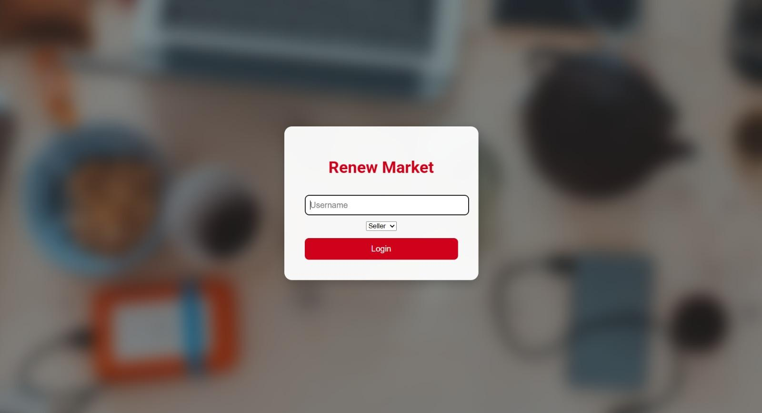
FIGURE 1: LOGIN PANNEL

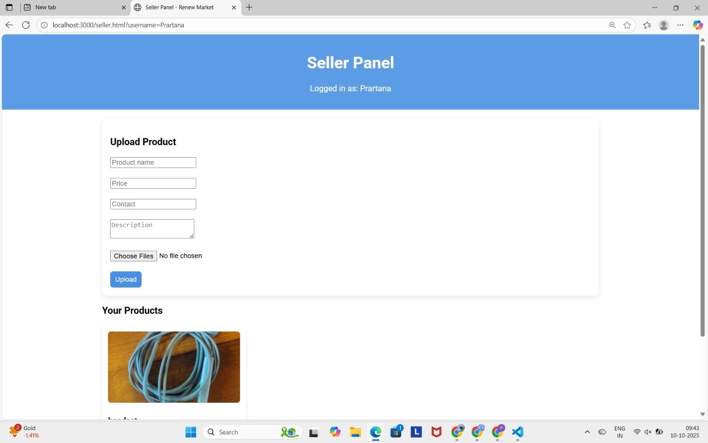
FIGURE 2: SELLER PANEL

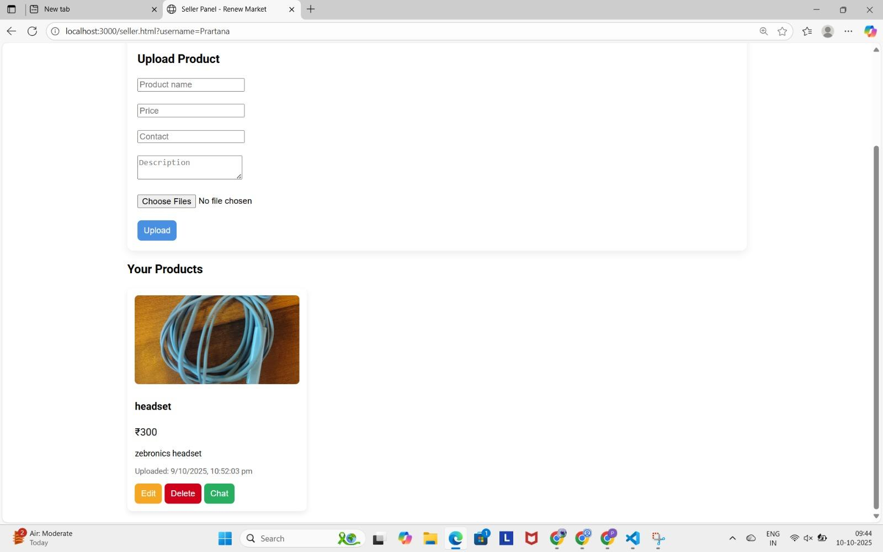
FIGURE 3 : PRODUCTS IN SELLER PANEL

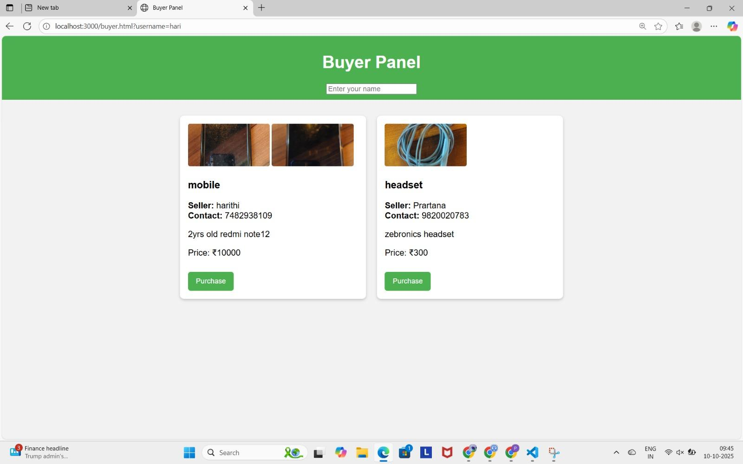
FIGURE 4: BUYER PANNEL

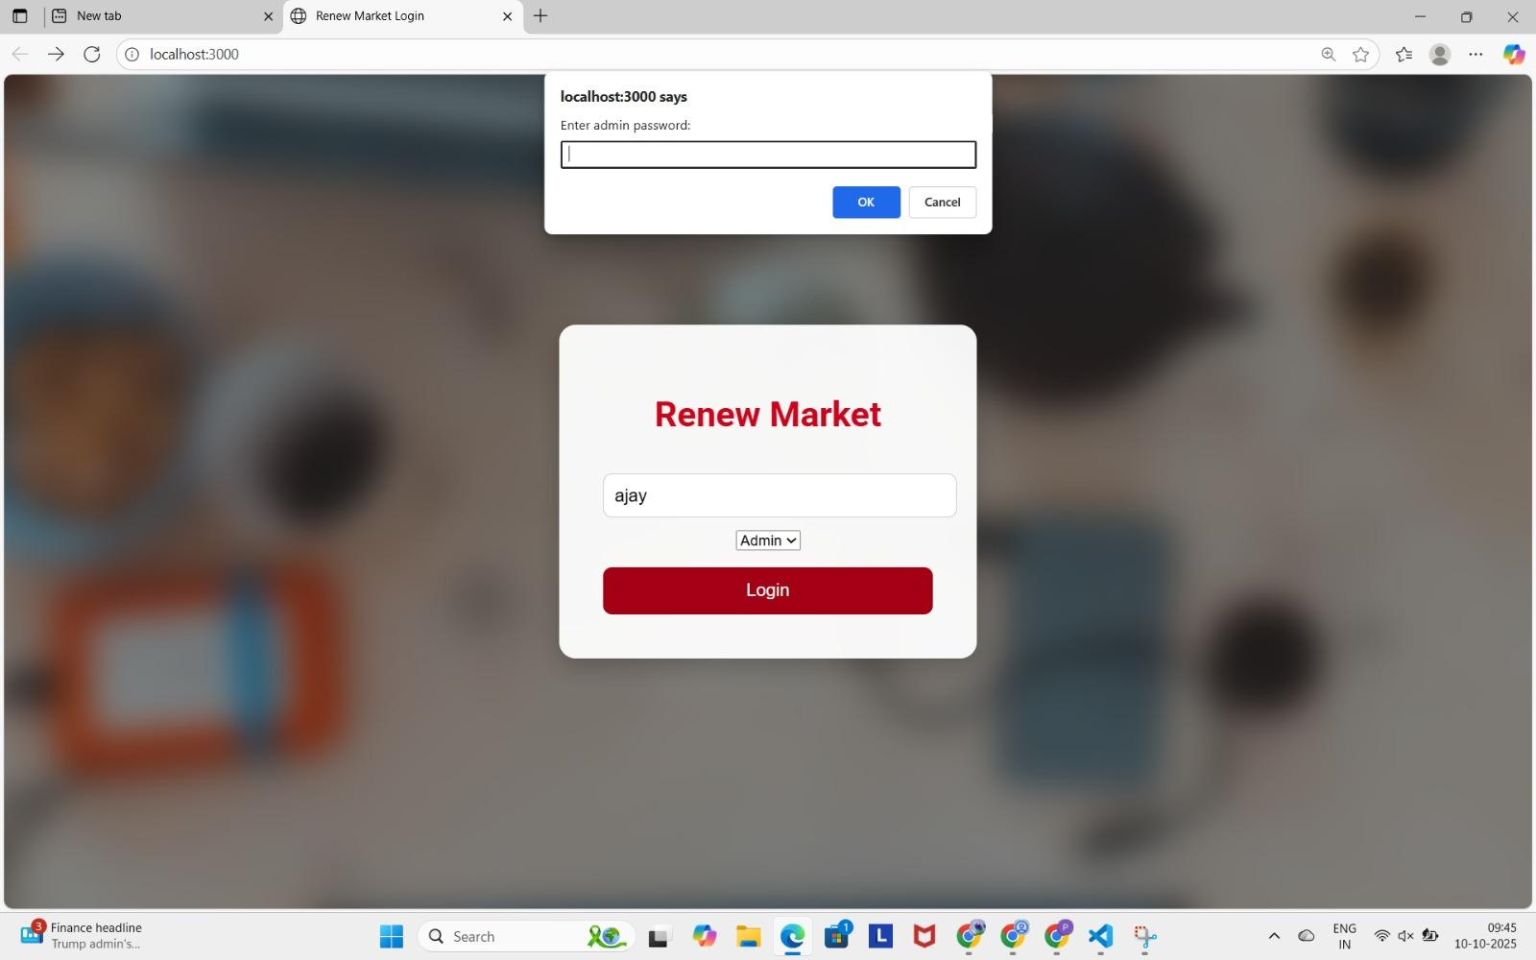
FIGURE 5: ADMIN LOGIN

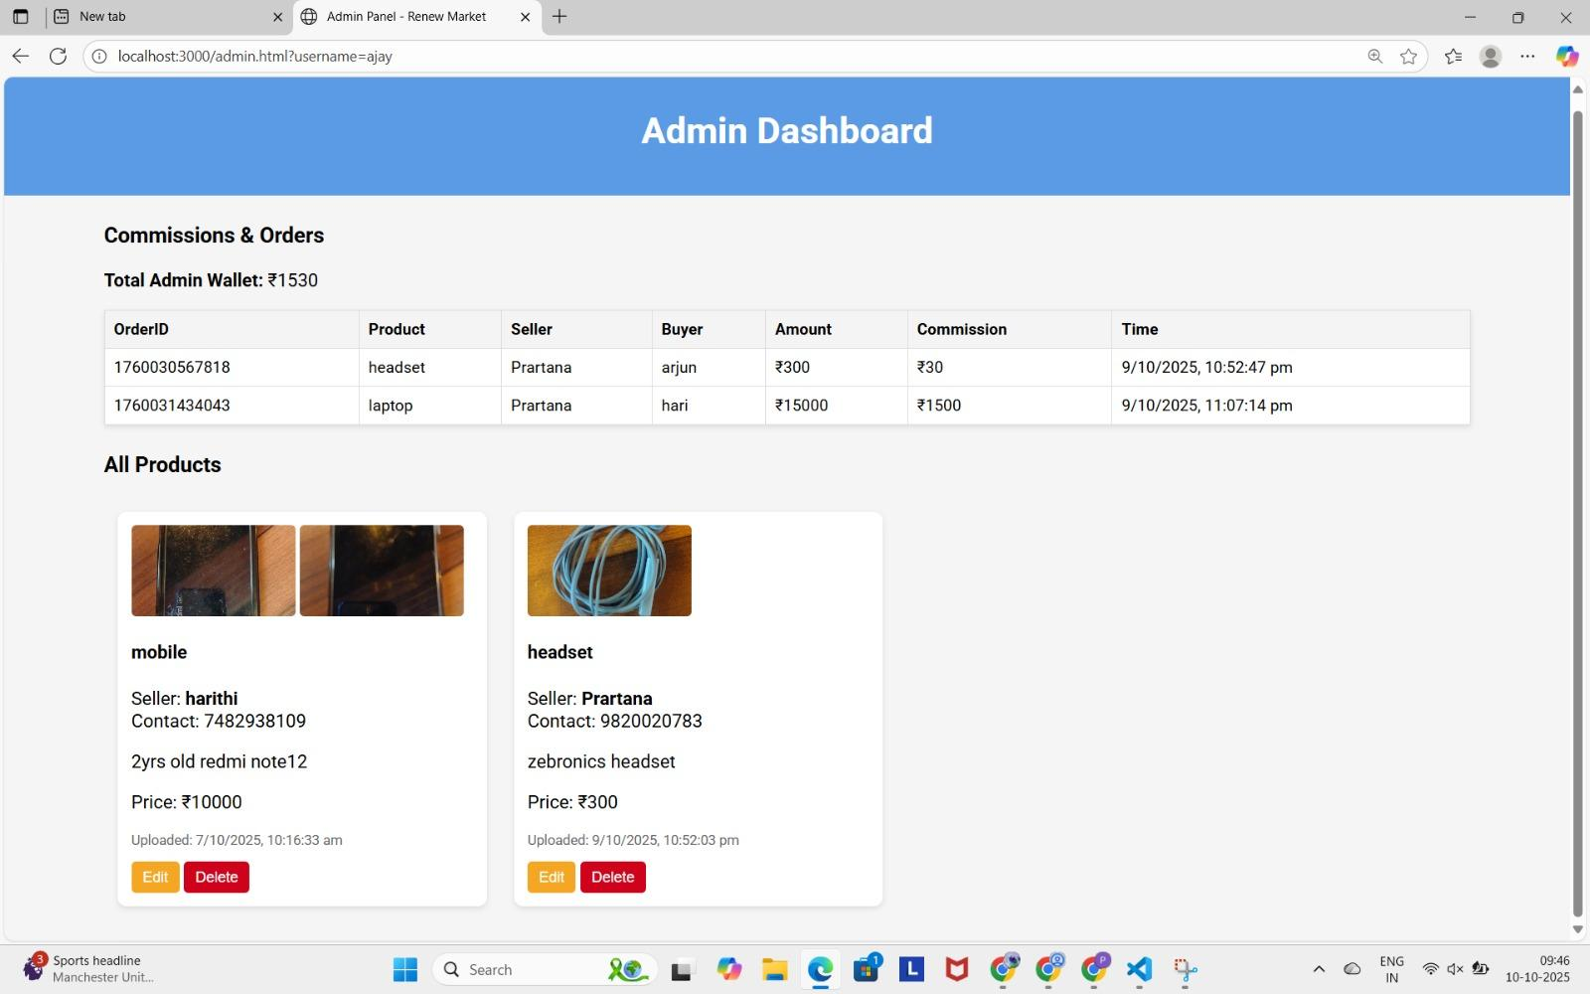
FIGURE 6: ADMIN DASHBOARD

